WORK PLAN FOR THE MONTH OF
OCTOBER AND NOVEMBER- 2021
CLASS-VIII

Dear Parents,
In these months, your child will be able to learn:

ENGLISH:

MATHEMATICS:
Chapter 10 – Visualizing Solid Shapes
Chapter 11 – Mensuration
Chapter 12 – Exponents and Powers
Chapter 13 – Direct and Inverse Proportions
Learning Objectives:
Students will be able to: identify solid figures.
Name solid figures according to their properties.
Name solid figures in the environment.
Recognizing informal units of measurements.
Justifying accuracy of Standard units of measurements.
Relating length,breadth,perimeter ,area.
Solve real life problems involving direct and inverse proportion (by unitary method)

COMPUTER:

Chapter 6: Communication Technology

Learning Objectives:
Students will learn about the various technologies used in networking
Students will also learn about the types of networks
Students will also learn about topologies

SCIENCE:

Chapter: 11: Force and Pressure
Chapter: 12: Friction

Learning Objectives:

.Forces from all perspectives and connotations: Force as a push or pull, Force as an agent of change, capable of changing the state of rest or motion or shape or configuration. Force as Contact and Non-contact forces. Understanding muscular force and friction as contact forces. Understanding Gravitational force, Electrostatic force and magnetic force as non-contact forces: Muscular force and Frictional forces as contact forces; Electrostatic force, Gravitational Force and concept of magnetic force as non-contact forces.
• Understanding how the concept of force leads to Thrust and pressure. Pressure in Solids, Liquids and gas. Atmospheric pressure
• Understanding force of friction, Factors affecting friction, kinds of friction, controlling friction, Fluid friction
• Solving numericals to bring clarity to concept.

Skills:

- Focus of cognitive Thinking / Making sense of abstract ideas for learning concepts.
- Experimenting (activity based), making observations, analyzing & drawing inferences.
- Observing, comparing, analysing and Inferencing.

Chapter:13 Sound
Chapter: 14: Chemical Effects of Current
Chapter: 15 Some Natural Phenomena

Learning Objectives:
- Understanding sound as an energy through different kinds of sounds originating from different sources, How this energy (sound) travels in different mediums, characteristics of sound, Factors affecting sound, How we can hear sounds, audible range of sound, Difference between sound, noise, music, Noise pollution
• Exploring and understanding if liquids / water /solutions can conduct electricity like metals and finding the reasons thereof. To know and learn the application of this property of liquids conducting current (i.e. applications of chemical effects of current).
• Understanding: (1) Electric charge in the light of certain natural phenomena like lightening, rubbing effects between clothes, types of charges and the way they interact. (2) Thunderstorm. (3) Earthquakes: why they occur, seismic zones and protection measures / mechanisms which we can adopt against their occurrences.

Skills:
- Focus of cognitive Thinking / Making sense of abstract ideas for learning concepts.
- Experimenting (activity based), making observations, analyzing & drawing inferences.
- Observing, comparing, analysing and Inferencing.

HINDI:

पाठ 11- जब सिनेमा ने बोलना सीखा
पाठ – 11 सुदामा चरित

व्याकरण -वाक्य भेद
व्यवहारिक ज्ञान -विद्यार्थियों को
भारतीय सिनेमा के विकास से परिचित कराना
विद्यार्थियों को भक्ति काल से परिचित कराना

Sanskrit:

पाठ-8 संसार सागरस्य नायक :
पाठ -9सप्त भगिन्य:
व्यवहारिक ज्ञान
1- विद्यार्थियों को भारतीय संस्कृति की जानकारी प्रदान करना
2-विद्यार्थियों को शिल्प कला के महत्व से परिचित कराना

S.St.:

History.:

Chapter 7- Civilizing the Native,Educating the nation

Learning objectives: Explains the institutionalization of the new education in India

Chapter:8- Women,Caste and Reform

Learning objectives
1)Discuss why so many reforms focused on the women’s question,and how they visualized a change in women’s condition.
2)Outline the history of new laws that affecf women’s lives.
3)Illustrate how autobiographies,biographies can be used to reconstruct the histories of women.

Geography.:

Chapter:5- Industries
Classifies different type of Industries based on raw materials,siz and ownership

Civics.:

Ch 6.Understanding our criminal justice system

Learning Objectives:
1.What is the role of the police in investigating the crime
2.First information report 3.What is the role of the public prosecutor
4.What is the role of the judge
5.What is a fair trial.

Skills:- Elaboration, Reading, Writing, Discussion and Mind Mapping.

Ch 7.Understanding Marginalization

Learning Objectives:
1. Who are adivasis l
2.Stereotyping adivasis
3.Adivasis and development
4.Minorities and marginalisation
5. Muslims and marginalisation

Skills: - Reading, Writing, Discussion and Mind Mapping

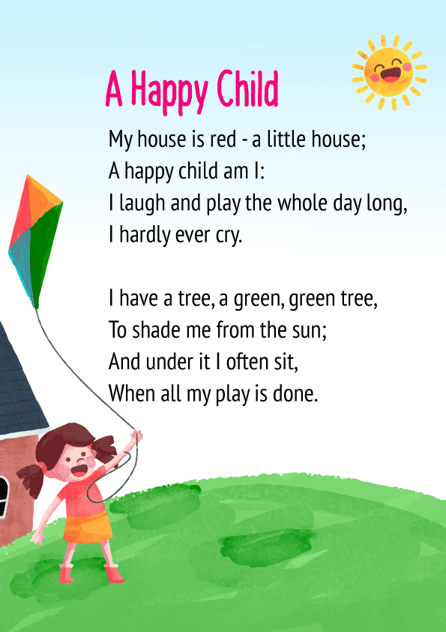

HINDI POEM :-

सुख करता दुखहर्ता, वार्ता विघ्नाची
नूर्वी पूर्वी प्रेम कृपा जयाची
सर्वांगी सुन्दर उटी शेंदु राची
कंठी झलके माल मुकताफळांची

जय देव जय देव, जय मंगल मूर्ति
दर्शनमात्रे मनःकमाना पूर्ति
जय देव जय देव

रत्नखचित फरा तुझ गौरीकुमरा
चंदनाची उटी कुमकुम केशरा
हीरे जडित मुकुट शोभतो बरा
रुन्झुनती नूपुरे चरनी घागरिया

जय देव जय देव, जय मंगल मूर्ति
दर्शनमात्रे मनःकमाना पूर्ति
जय देव जय देव

श्लोक

वक्रतुण्ड महाकाय सूर्यकोटि समप्रभ ।
निर्विघ्नं कुरु मे देव सर्वकार्येषु सर्वदा॥

अर्थात :

“हे हाथी के जैसे विशालकाय गणेश, जिनका तेज सूर्य की सहस्त्र किरणों के समान है, सदा मेरे सभी कार्य बिना किसी विघ्न के पूर्ण करें”।

दोहा

तुलसी नर का क्या बड़ा, समय बड़ा बलवान|
भीलां लूटी गोपियाँ, वही अर्जुन वही बाण||

अर्थात :

तुलसीदास जी का कहना हैं, समय बड़ा बलवान होता है, वो समय ही है जो व्यक्ति को छोटा या बड़ा बनाता है| जैसे एक बार जब महान धनुर्धर अर्जुन का समय ख़राब हुआ तो वह भीलों के हमले से गोपियों की रक्षा नहीं कर पाए|

YOGA:

- Balayam
- Tadhansa
- Brahmri
- Bhastrika

ART & CRAFT:

- Thank you card for teacher
- Ganesh ji making with clay dough
- Landscape drawing
- Learn how to draw a bird

MUSIC AND MOVEMENT:

- Foo foo
- Phonic song

Stay safe and take care!

Thank you
Ms. Tanshi Shrivastava
Class-I

